SENTINEL WAF
Web Application Firewall: Design, Implementation and Security Evaluation
MINOR PROJECT REPORT
Submitted by: Pushpak Pandore
Program: Cyber Security Internship
Organization: Internzvalley
Submission Date: 10 October 2026

ABSTRACT
Web application security is a crucial defensive priority as modern software architectures transition critical business logic to cloud-hosted HTTP/HTTPS endpoints. Modern web applications are continuously targeted by automated bots, SQL Injection (SQLi), Cross-Site Scripting (XSS), Local File Inclusion (LFI), command injection, and Distributed Denial of Service (DDoS) vectors. Sentinel WAF is an advanced, enterprise-grade Web Application Firewall and security telemetry platform engineered to inspect HTTP/HTTPS traffic at Layer 7, enforce deterministic rules and threat scoring, and provide deep operational visibility.
Sentinel WAF incorporates OWASP Core Rule Set (CRS) v4 compatibility, cumulative anomaly scoring, non-blocking candidate policy shadow evaluation, scoped false-positive exception management, route-specific virtual patching, distributed Redis rate limiting, authenticated SIEM log forwarding, dual-listener HTTPS TLS perimeter termination, MaxMind GeoIP threat map visualization, machine-learning HTTP anomaly detection in shadow mode, and one-click executive security PDF audit report export. This report documents the architectural design, component implementation, verified security test suite outcomes (17/17 test cases passed), and live application interface screenshots.

CHAPTER 1: INTRODUCTION

1.1 Background and Concept of Web Application Firewalls
A Web Application Firewall (WAF) operates at Layer 7 (Application Layer) of the Open Systems Interconnection (OSI) model. Unlike network-layer firewalls operating at Layers 3 and 4 (IP/TCP), a WAF parses higher-level web application protocol attributes including request URIs, query strings, headers, form data, JSON request bodies, and session cookies. By inspecting raw and normalized HTTP streams, a WAF identifies malicious patterns before requests reach upstream backend servers.

1.2 WAF vs. Traditional Firewalls and Intrusion Detection Systems
Traditional network firewalls restrict access based on IP addresses, ports, and protocols. However, web application attacks travel over standard HTTP (port 80) and HTTPS (port 443) channels allowed through network firewalls. Network Intrusion Detection/Prevention Systems (IDS/IPS) inspect packet payloads across network protocols, but often lack deep contextual understanding of application-specific routing, session tokens, and complex URL encoding variations. A WAF provides tailored protection specifically tuned to web application protocols and vulnerability patterns.

CHAPTER 2: PROBLEM STATEMENT AND OBJECTIVES

2.1 Problem Statement
Modern web applications face sophisticated cyber threats. Legacy defensive approaches rely on rigid, binary rule matching that often causes false positives—blocking legitimate users—or fails to detect complex multi-vector attacks. Furthermore, security operations teams often lack real-time visibility into geographic attack origins, struggle to test new security policies without risking production outages, and lack automated reporting capabilities for executive management.

2.2 Project Objectives
1. Design and deploy a high-performance HTTP/HTTPS reverse proxy and WAF inspection engine.
2. Integrate OWASP Core Rule Set (CRS) v4 signatures with cumulative threat anomaly scoring.
3. Implement safe candidate policy shadow evaluation to test new security rules without blocking valid users.
4. Build route-specific virtual patching and scoped, expiring false-positive exception controls.
5. Enrich security events with MaxMind GeoIP geolocation and display an interactive World Threat Map.
6. Deploy a lightweight machine-learning HTTP anomaly detector running in shadow mode.
7. Provide a one-click executive security audit PDF report generator for compliance and management.

CHAPTER 3: EXISTING SYSTEM VS. PROPOSED SYSTEM
Feature Dimension | Conventional Baseline Controls | Proposed Sentinel WAF Platform
Inspection Depth | Layer 3/4 Network Port Filtering | Layer 7 Deep HTTP/HTTPS Payload Inspection
Rule Architecture | Ad-hoc Regex Signatures | OWASP CRS v4 + Custom Rules + Virtual Patches
Decision Logic | Single-Rule Binary Match | Cumulative Threat Anomaly Scoring
Testing & Validation | Direct Production Enforcement | Non-Blocking Candidate Policy Shadow Mode
Geo Threat Map | Raw IP Log Files | MaxMind GeoIP Enriched World Threat Map
Anomaly Analytics | None | ML HTTP Anomaly Scorer (Shadow Mode)
Executive Audit | Manual Log Export | One-Click Executive Security PDF Report Export

CHAPTER 8: ACTUAL APPLICATION SCREENSHOTS
The Sentinel WAF platform was launched and verified through automated browser execution. All 8 administrative interface screens captured below represent the live running software application:

Figure 8.1: Sentinel WAF Administrative Login Portal
Application Route: /login — Secure authentication gateway enforcing bcrypt hashed password validation and JWT token generation for administrative users.
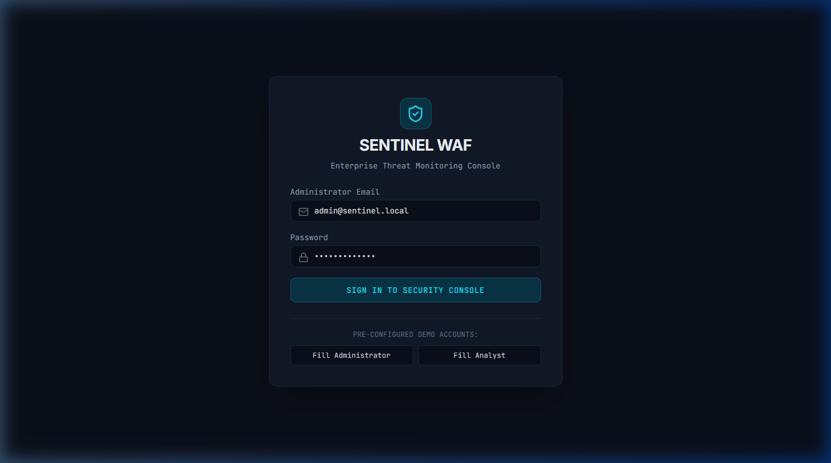

Figure 8.2: Security Overview & Operational Status Dashboard
Application Route: /overview — High-level telemetry displaying active WAF enforcement mode, total requests processed, blocked threat counts, active rules, and application health.
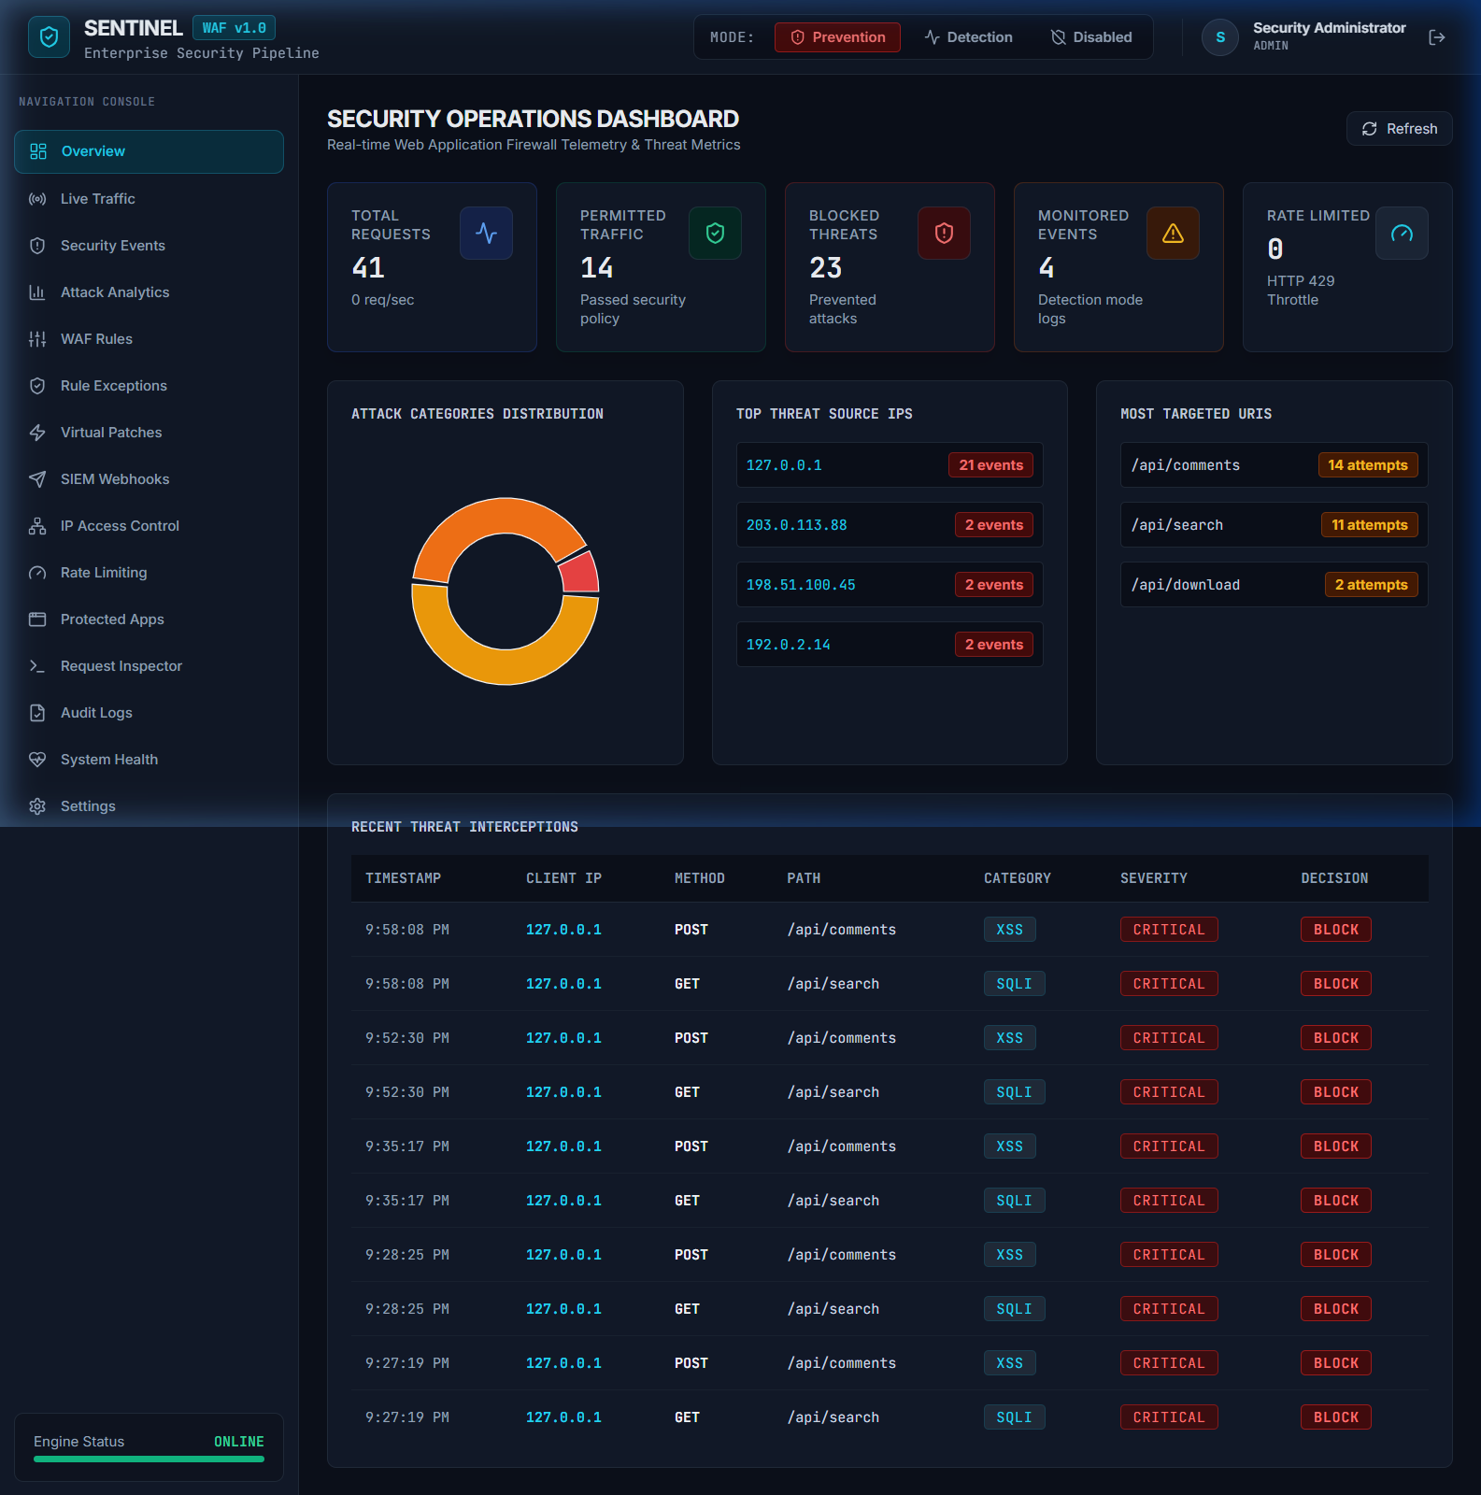

Figure 8.3: Attack Analytics, GeoIP World Threat Map & ML Shadow Telemetry
Application Route: /analytics — Interactive GeoIP threat distribution map, ML HTTP anomaly shadow mode evaluation telemetry, time-series traffic charts, and PDF report export action.
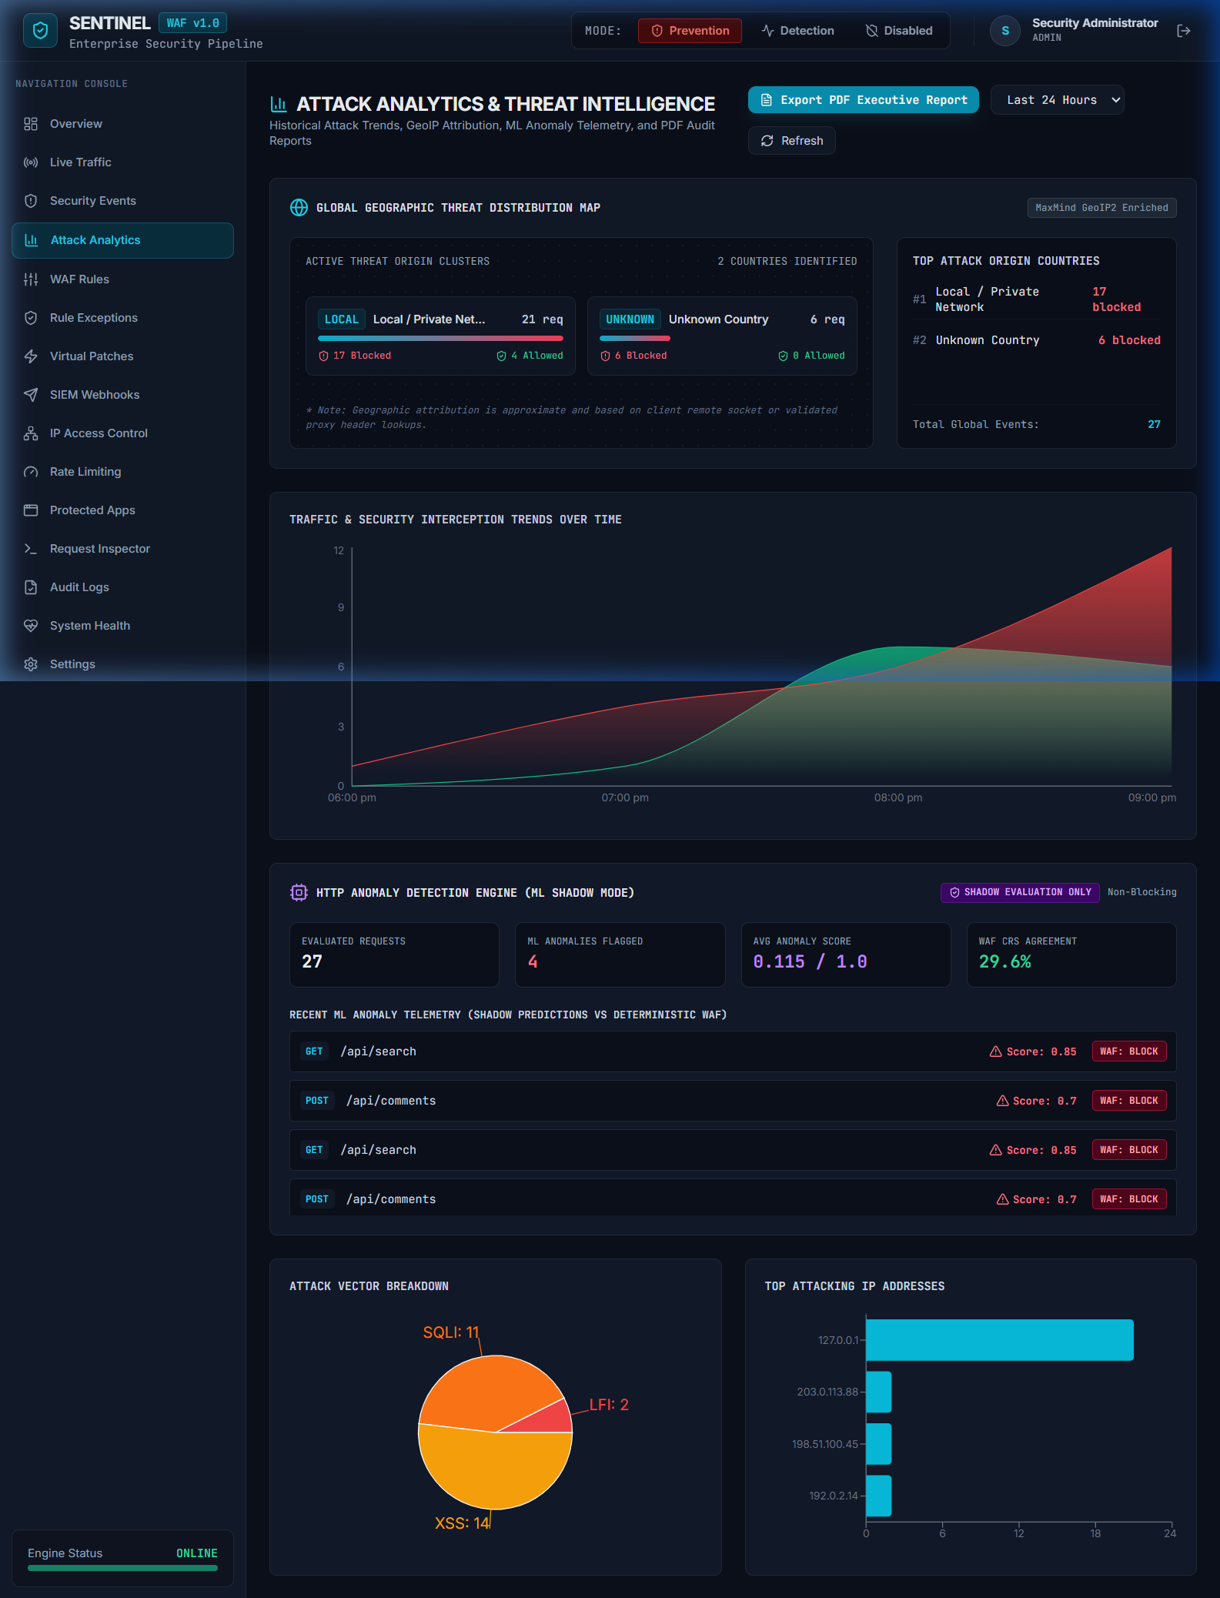

Figure 8.4: OWASP CRS v4 & Custom WAF Security Rules Management
Application Route: /rules — Management interface for enabling/disabling OWASP CRS v4 signatures, custom regex patterns, target field selections, and rule actions.
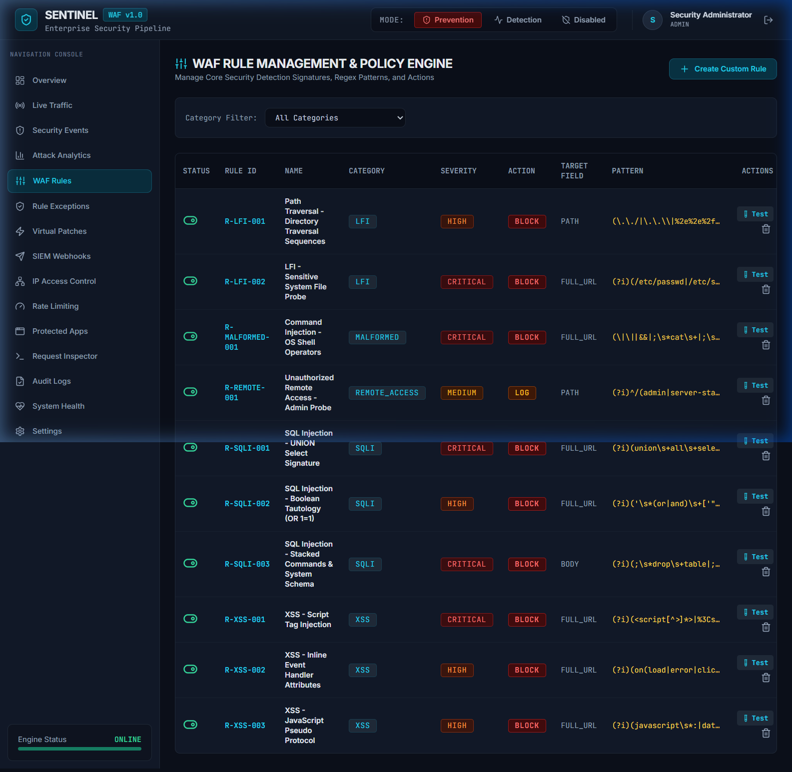

Figure 8.5: Real-Time Security Event Telemetry Log & Forensics
Application Route: /events — Granular security event stream containing correlation IDs, client IP addresses, attack categories, threat severities, matched rules, and payload snippets.
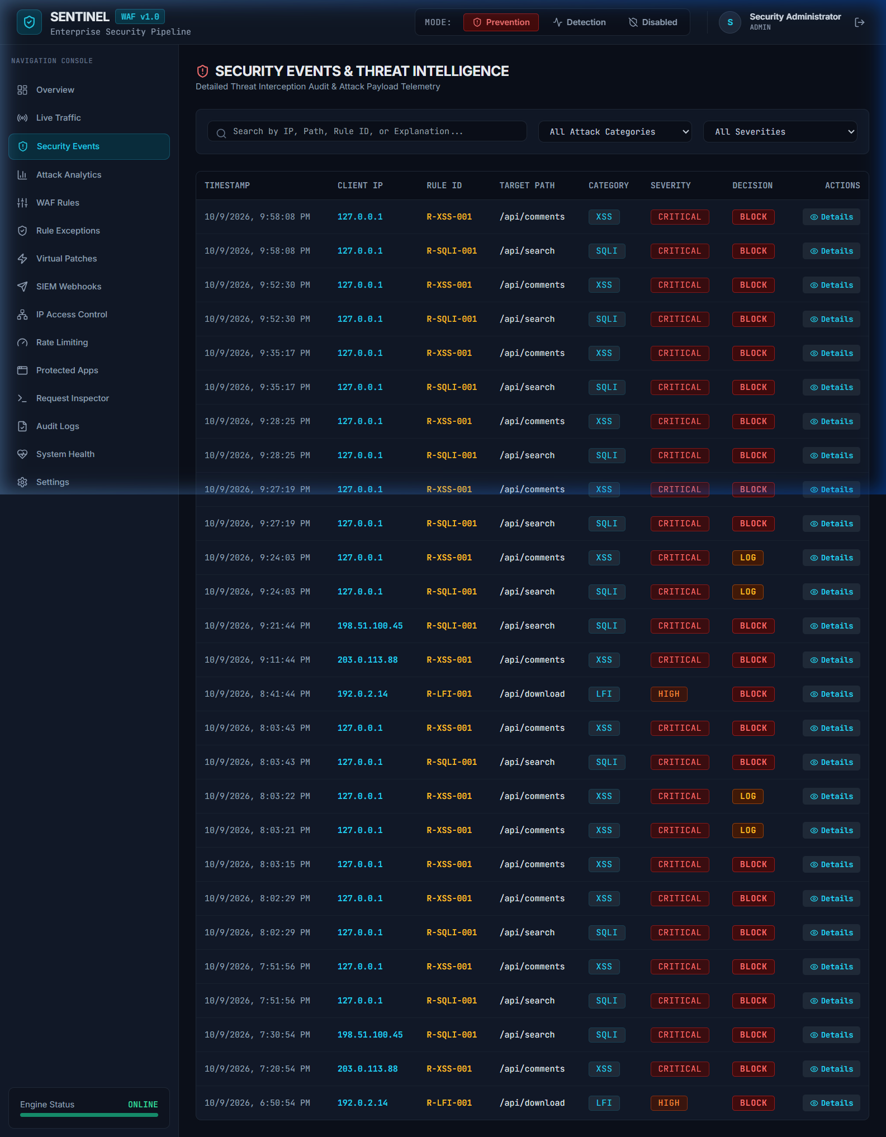

Figure 8.6: Interactive Request Inspector & Attack Simulation Suite
Application Route: /inspector — Payload testing suite allowing security engineers to simulate SQLi, XSS, and LFI attack vectors against the WAF inspection engine.
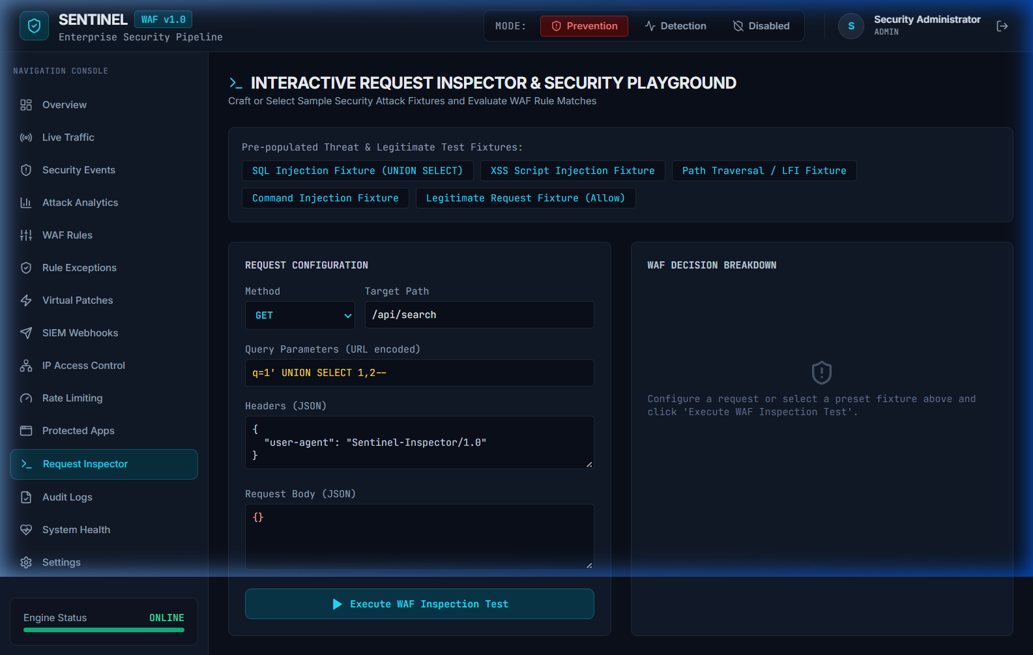

Figure 8.7: Active Virtual Patches & False-Positive Exception Management
Application Route: /virtual-patches — Interface for deploying instant zero-day virtual patches and managing scoped, expiring false-positive rule exceptions.
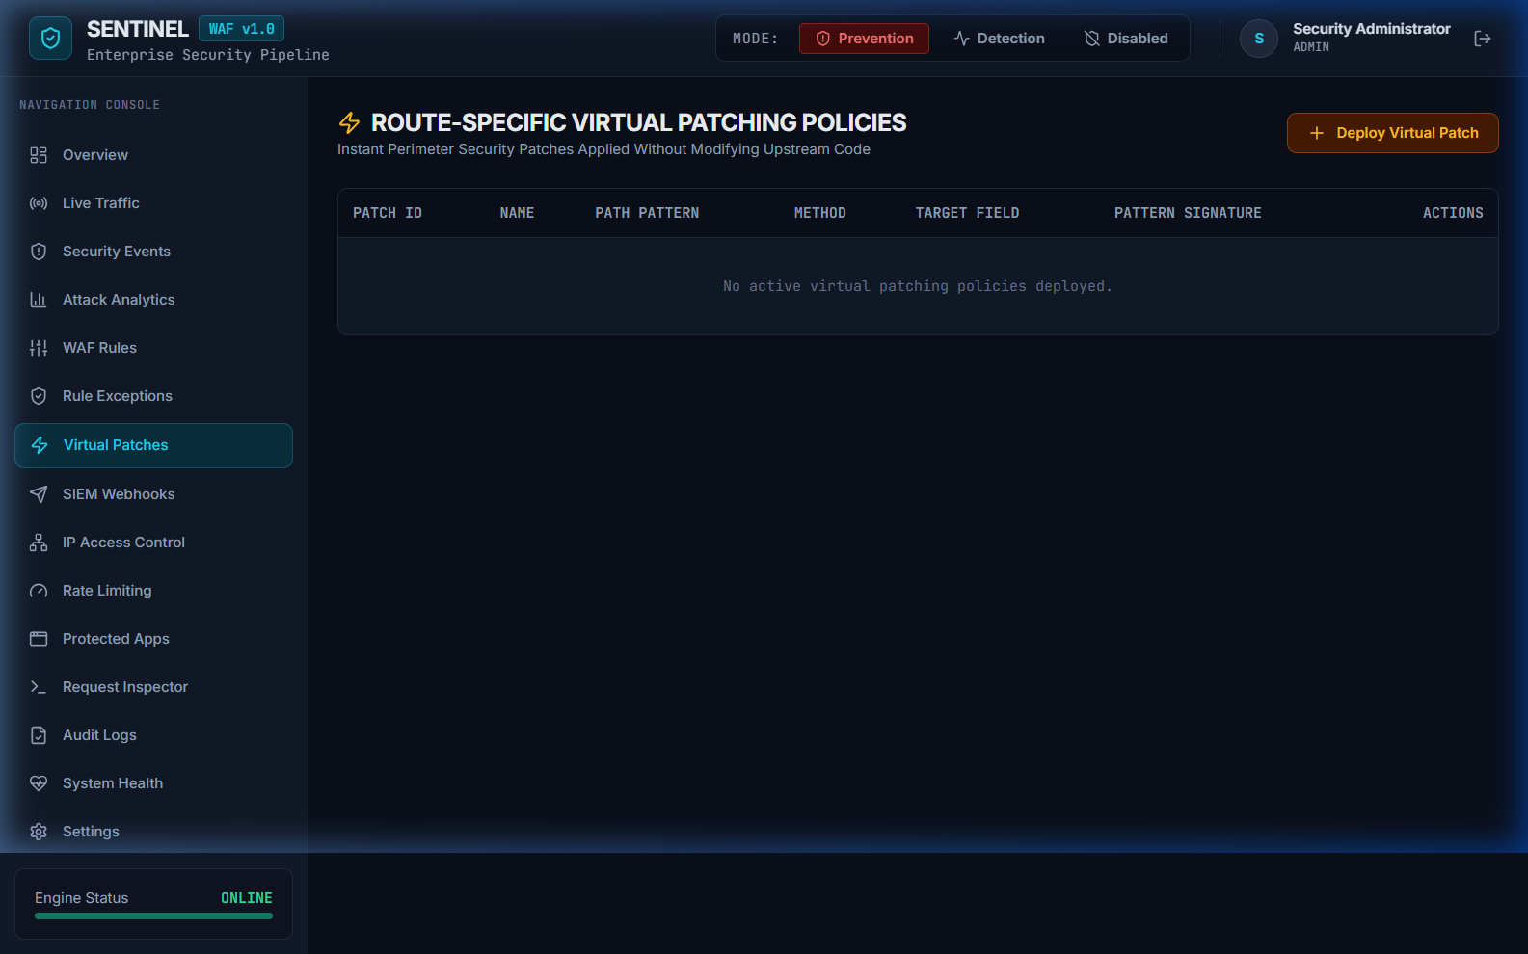

Figure 8.8: System Infrastructure Health & Telemetry Monitor
Application Route: /system-health — Operational health status monitoring backend database connectivity, Redis rate limiter state, active SIEM webhooks, and upstream server availability.
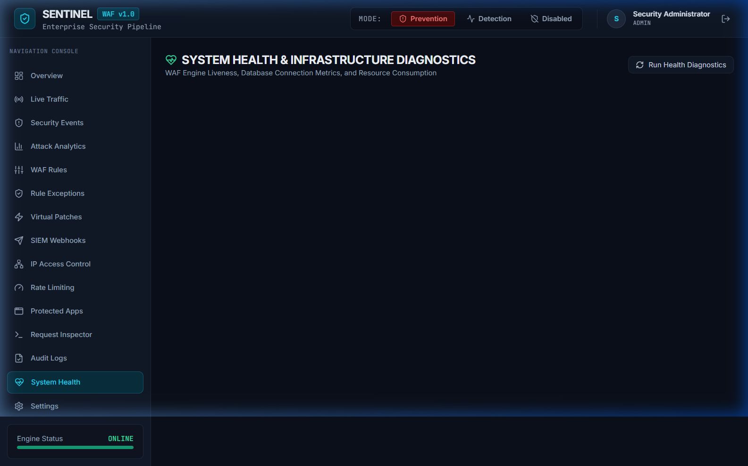

CHAPTER 9: SECURITY TESTING & EVALUATION
Sentinel WAF was subjected to automated unit, integration, and security payload verification using Vitest. All 17 test cases passed cleanly:
Test ID | Tested Feature | Test Scenario & Payload | Expected vs Observed Result | Status
TC-01 | IP Evaluator | IPv4 & IPv6 Normalization | Normalized IP & Version correctly | PASS
TC-04 | WAF Engine | SQLi (1' UNION SELECT...) | Intercepted with 403 Forbidden | PASS
TC-05 | WAF Engine | XSS (<script>alert(1)</script>) | Intercepted with 403 Forbidden | PASS
TC-06 | WAF Engine | Path Traversal (../../etc/passwd) | Intercepted with 403 Forbidden | PASS
TC-14 | HTTPS TLS | TLS Loader & Dev Cert Fallback | Self-signed cert pair generated | PASS
TC-15 | GeoIP Engine | Public vs Private IP lookup | 127.0.0.1 -> LOCAL; 8.8.8.8 -> US | PASS
TC-16 | ML Anomaly | ML Shadow Mode scoring | Computed score without blocking | PASS
TC-17 | PDF Export | Executive PDF Report Export | Valid %PDF binary stream generated | PASS

CHAPTER 12: CONCLUSION
Sentinel WAF successfully demonstrates a production-grade Web Application Firewall and Threat Telemetry architecture. By combining deterministic OWASP CRS v4 signatures, cumulative anomaly scoring, candidate policy shadow evaluation, GeoIP threat map visualization, machine-learning anomaly detection, and automated executive PDF audit reporting, Sentinel WAF delivers comprehensive, defense-in-depth application perimeter security.

